Nowadays, people are too busy that they rarely have time to go outside and have a meal at a restaurant. What if people can have a perfect meal from any restaurants they want at home or anywhere they want at any time? Yes, actually there are a lot of useful online order platforms now such as uber-eat, but what I meant by perfect meal is that the applications can provide users with functions exactly the same as when they are ordering at a restaurant. I would like to call it “AI chef”.

Talking a few things about myself, I have a part-time job in a Vietnamese restaurant in Richmond. We are currently using uber-eat as a way of online ordering. However, not only the restaurant’s staff found out there are a lot of disadvantage using this feature, the orderers also sometimes come up against trouble because of lacking functionality. As a staff member, sometimes we are confused of what the orderer wants, and may make mistake from that. In addition, uber cannot tell full contents of the food so it is really difficult for some people who have allergies, special health condition or who are vegetarians. As an IT student, I come up with an idea creating an AI (online BOT in other word) that can easy for users to use

My project is focusing on creating a website and an application that contains AI support. There will be 2 different types of app: for customers and for restaurants.

1. Customer app/website:

In my imagination, in the home page should be the introduction of the restaurant (including location, opening hours, kind of food, etc. – all the things that the visitor would like to know about first). Then there is a main feature which is AI chef. Basically, AI chef is an automatic bot that can provide help exactly like human. Here are some of the functions that users can use from AI chef:

+Order: this is like the way most of the other online order apps can provide, except that orderers here are talking directly to the bot and the bot can propose a variety of options to buyers. Bot could ask how spicy customers want the food to be or what type of dipping sauce customers want for the food. Bot can receive both typing messages and voice messages by analyzing some of the specific key words before sending all the details back to the restaurant so that users can have a perfect meal that they want.

+Food suggestion: this is for customers who have not been to the restaurant before and they do not the food exactly. So this function can provide user descriptions of specific recipe, what it contains and who or when it is suitable for. This can help vegetarians and people with allergies avoid choosing the wrong food. Another feature is that bot can suggest customers with best-sellers, traditional, best offers, available discounts

+Special order: this is a feature that can make it possible for customers to customize their food by adding or removing something from contain. This also provide users with the ability to design their own food for special price the restaurant set. It is very useful if you order fast food, like pizza, wrap, hamburger or even a cake. It is suitable for special events such as birthday, celebration day, party, etc.

+Food quality checking system: bot is programmed to check the food quality if it meets requirements before being delivered. The bot can check the contains whether it matches with what the customer has ordered, the temperature of the food, detail if customer choose design function, shape of the food, etc. this feature can let customers experience exactly the same as being in the restaurant while being at home.

+Delivery tracking system: this function helps users track down the deliverer where he/she is at a point of time and when he/she arrives. It also provides information of the deliverer so that customers can easily pick up their food.

+Rating, feedback: last but not least, there should be the rating and feedback feature so that customer can tell what they like or dislike about that restaurant, which can help the restaurant to improve themselves. This feature also let users share the restaurant via social media like Facebook, Instagram, etc.

Furthermore, my project plan to have some additional feature for the website and app:

+Search restaurant: able to search for the nearest restaurant, different type of restaurant user would like to choose, from economical ones to luxury ones.

+Help/instruction: brief instruction on how to use all the feature.

+Feedback, contact support detail: email provide, support in person.

+Different languages support: worldwide use.

1. Restaurant app/website:

The app/website for restaurant requires provision of detailed menu with price, available food, working hours, location, food recommendation, etc. to function customer web/app from the restaurant.

Right after customer order the food, detail information will be sent back to the restaurant and they just need to confirm that. When finishing the food, staff need to confirm again on the app/web so the app can immediately send back to the customers and let they know that their food is ready.

So here is my solution for this, using web service:

Firstly, the administrator, who is the restaurant owner, has to store all the information of the food inside the database. When the users order from web/app, information will be sent to “Application” through web service and then “Application” will check the database. if everything meets the requirement, it will accept the order and send it to the third party which is the bank. When transfer is successful, the order will send to administration web/app. then restaurant confirms it and start making food.

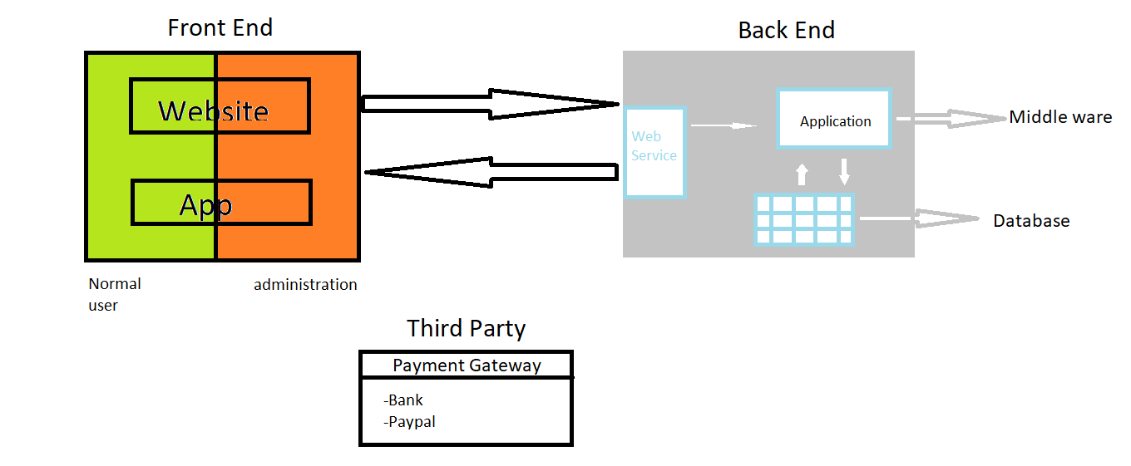

To do this project successfully, I will need to know how to use different concepts: Front End and Back End contains. To create Back-End, there is a various way such as using AWS, google cloud… so a big amount of money should be invested. The Third Party is easy to get whenever those Front End and Back End finish. This project is required a lot of knowledge and money, however, the outcome would be outstanding. This web/app can help people to save a lot of time, as well as satisfy themselves with the meal they want. For the restaurant using these features, owners can get more income to their restaurants and easier to get an order from customers.